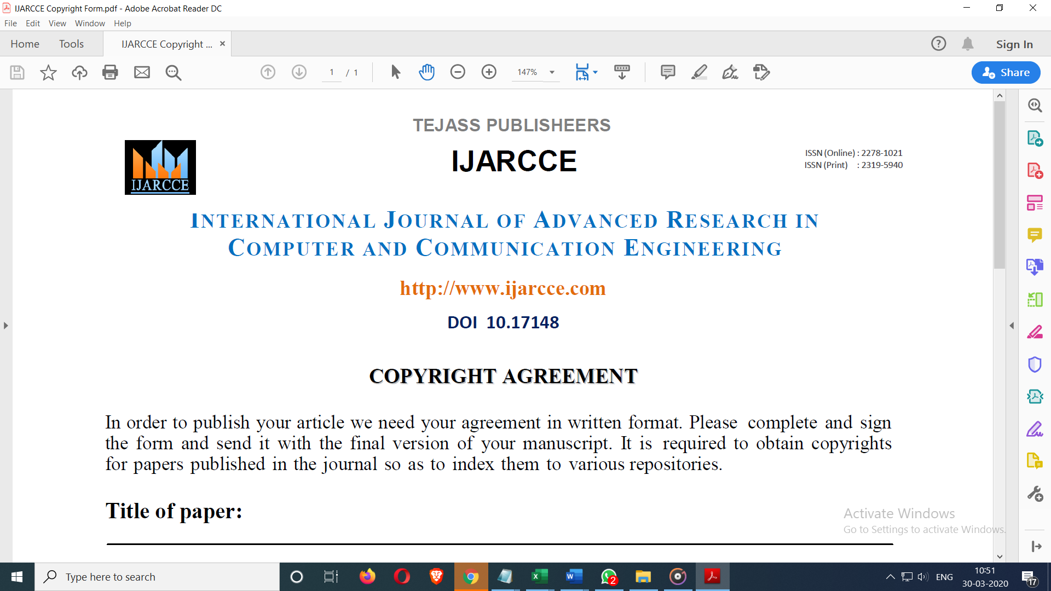

**Don’t take PRINT**

← type details

# Title of paper: NATURAL LANGUAGE PROCESSING ANALYSIS WEBSITE USING PYTHON/DJANGO

**Author’s Name: Nanthakumar J J, Praveen K, Nirmal Kumar N**

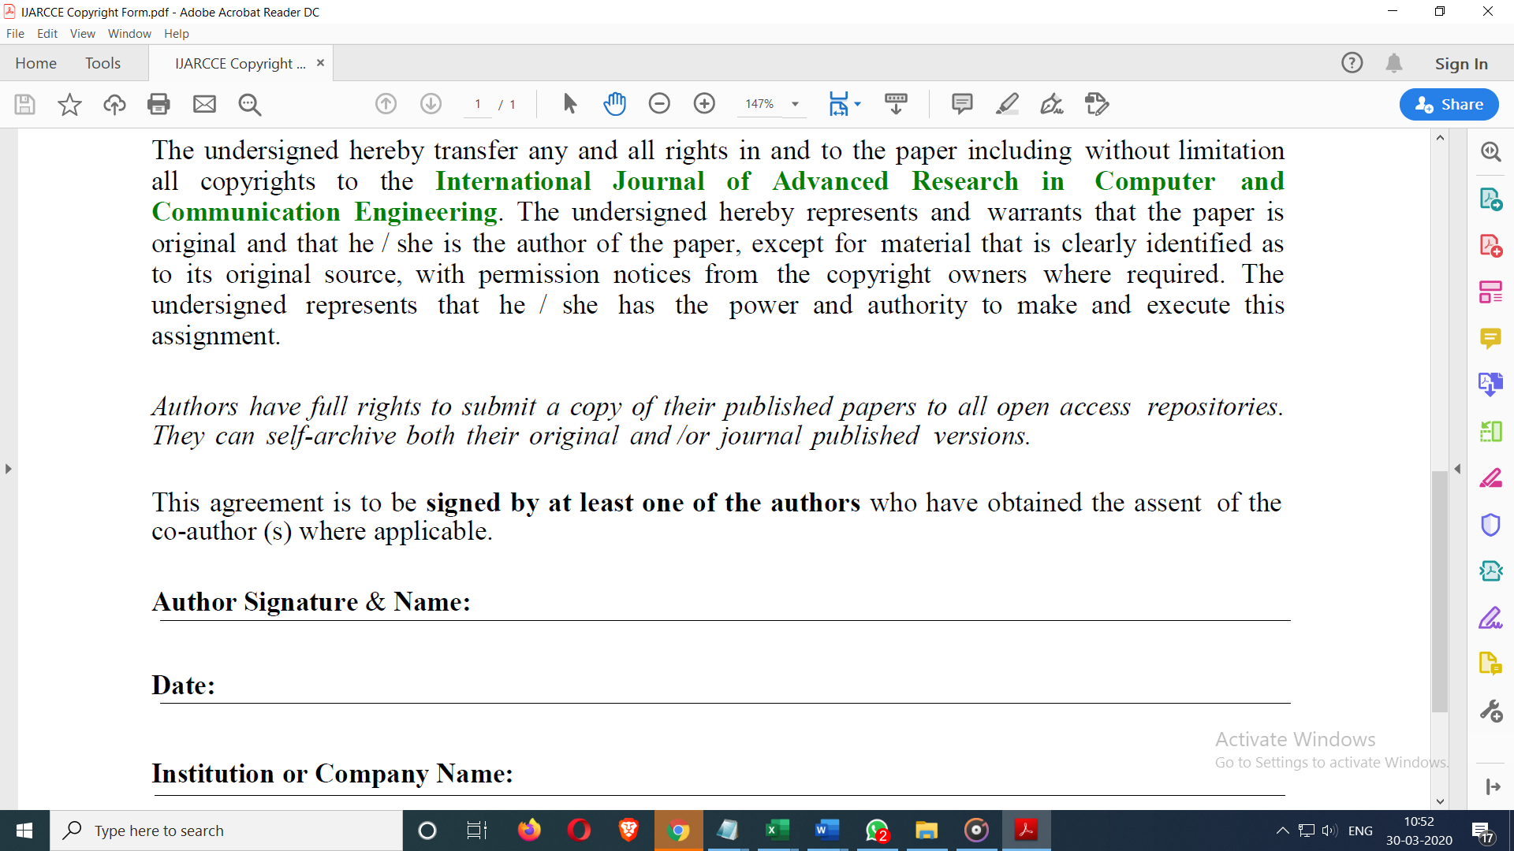

← type details

**Author Name: Nanthakumar J J**

(anyone)

**College/University Name: Panimalar Engineering College**

**Date: 28/06/2021**

